Student Name : CHALLA RAVITEJA
Register Number : 192325065

CO1_AT3
MLA0201 – FUNDAMENTALS OF MACHINE LEARNING LAB PROGRAMS
Application – Based Questions

PROGRAM 1:
AIM:
To calculate the probability of Malignant and Benign classes using the Breast Cancer Wisconsin Diagnostic Dataset and predict the class of a new data instance.

CONCEPT: Prior Probability Classification using Probability Theory
Probability Theory is a mathematical approach used to measure the likelihood of an event occurring. In Machine Learning, probability helps in making predictions based on historical data. In this experiment, the Breast Cancer Wisconsin Diagnostic Dataset is used to determine the probability of two classes: Malignant (M) and Benign (B). The program first loads the dataset and counts the number of samples belonging to each class. It then calculates the probability of each class by dividing the class count by the total number of records. These probabilities represent how frequently each class appears in the dataset. A new data instance is predicted by selecting the class with the higher probability. This method is known as prior probability-based prediction, as it does not consider individual feature values. It provides a simple understanding of probability concepts before moving to advanced probabilistic models. Thus, the program demonstrates how probability can be used for basic classification problems in Machine Learning.

PSEUDO CODE:
START
Load the dataset.
Count Malignant and Benign records.
Calculate probability of each class.
Compare both probabilities.
Display the probabilities.
Predict the class with higher probability.
STOP

PROGRAM:
import pandas as pd

# Load dataset (fallback to sklearn's built-in if CSV not found)
try:
df = pd.read_csv("breast_cancer.csv")
except FileNotFoundError:
from sklearn.datasets import load_breast_cancer
data_bc = load_breast_cancer()
df = pd.DataFrame(data_bc.data, columns=data_bc.feature_names)
# create a 'diagnosis' column using target names, map to 'M'/'B'
if data_bc.target_names[0].lower().startswith("mal"):
mapping = {0: "M", 1: "B"}
else:
mapping = {0: "B", 1: "M"}
df["diagnosis"] = [mapping[t] for t in data_bc.target]
# Count classes
malignant = (df["diagnosis"] == "M").sum()
benign = (df["diagnosis"] == "B").sum()
# Total records
total = len(df)

# Calculate probabilities
p_malignant = malignant / total
p_benign = benign / total
print("Total Records :", total)
print("Malignant :", malignant)
print("Benign :", benign)
print("\nProbability of Malignant :", round(p_malignant, 4))
print("Probability of Benign :", round(p_benign, 4))
# Prediction
if p_malignant > p_benign:
print("\nPredicted Class : Malignant")
else:
print("\nPredicted Class : Benign")

OUTPUT:
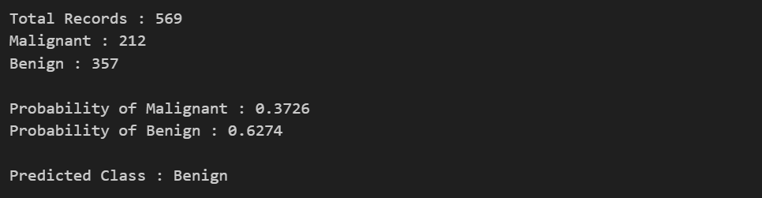

PROGRAM 2:
AIM:
To implement Bayes Decision Theory using the SMS Spam Collection Dataset and classify a given message as Spam or Ham based on posterior probability.

CONCEPT: Naïve Bayes Classification using Bayes Decision Theory
Bayes Decision Theory is a probabilistic approach used for classification based on Bayes' Theorem. It calculates the probability of a class after observing the available evidence, which is known as the posterior probability. In this experiment, the SMS Spam Collection Dataset is used to classify messages as Spam or Ham (Not Spam). The program first calculates the prior probabilities of Spam and Ham messages from the dataset. A new SMS message is then provided as input by the user. The program searches for common spam-related keywords such as free, win, cash, prize, offer, and claim in the message. Based on the presence of these keywords, the posterior probability for the Spam class is estimated and compared with the Ham probability. The class with the higher posterior probability is selected as the final prediction. Bayes Decision Theory is widely used in email filtering, message classification, medical diagnosis, and text mining because it is simple, efficient, and works well with probabilistic data. This experiment demonstrates how Bayesian classification can be applied to real-world spam detection.
PSEUDO CODE:
START
Load the dataset.
Calculate prior probability of Spam.
Calculate prior probability of Ham.
Read a new message.
Calculate posterior probabilities.
Compare posterior probabilities.
Display Spam or Ham.
STOP
PROGRAM:
import pandas as pd
# Create sample dataset
data = {
"label": ["spam", "ham", "spam", "ham", "spam", "ham", "spam", "ham", "spam", "ham"],
"message": [
"You won a free prize claim now",
"Hi, how are you doing today",
"Free cash offer winner click here",
"Let's meet for coffee tomorrow",
"Claim your prize now",
"Meeting at 3 PM tomorrow",
"Win big cash now",
"Just checking in with you",
"Free offer limited time",
"Thanks for your email"
]
}
df = pd.DataFrame(data)
# Count classes
spam = (df["label"] == "spam").sum()
ham = (df["label"] == "ham").sum()
total = len(df)
# Prior probabilities
p_spam = spam / total
p_ham = ham / total
print("Prior Probability of Spam :", round(p_spam, 4))
print("Prior Probability of Ham :", round(p_ham, 4))
# Input message
message = input("\nEnter Message : ").lower()
spam_words = ["free", "win", "winner", "cash", "offer", "claim", "prize"]
count = 0

for word in spam_words:
if word in message:
count += 1
posterior_spam = p_spam * (count + 1)
posterior_ham = p_ham
print("\nPosterior Spam Score :", round(posterior_spam, 4))
print("Posterior Ham Score :", round(posterior_ham, 4))
if posterior_spam > posterior_ham:
print("\nPrediction : Spam")
else:
print("\nPrediction : Ham")

OUTPUT:
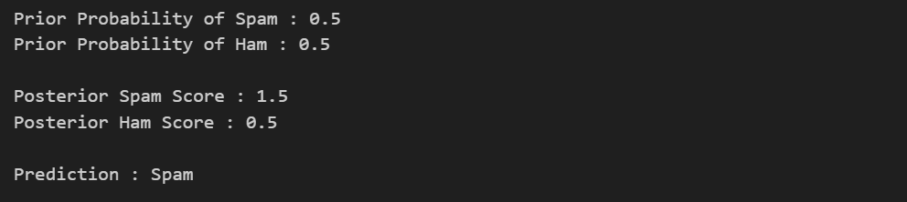

PROGRAM 3:
AIM:
To calculate the entropy and information gain for all input attributes using the Play Tennis Dataset and identify the attribute with the highest information gain.

CONCEPT: Entropy and Information Gain using Information Theory
Information Theory is a branch of mathematics that measures the amount of information present in a dataset. It plays a major role in Machine Learning, especially in Decision Tree algorithms. The two important concepts used in this experiment are Entropy and Information Gain. Entropy measures the uncertainty or impurity of the target class in the dataset. A higher entropy value indicates greater uncertainty, while a lower value indicates better classification. Information Gain measures how much uncertainty is reduced after splitting the dataset using a particular attribute. In this experiment, the Play Tennis Dataset is used to calculate the entropy of the target attribute and the information gain of all input attributes. The program computes the weighted entropy for every attribute and then calculates its information gain. Finally, the attribute with the highest information gain is identified as the best attribute for splitting the dataset. This attribute becomes the root node when constructing a Decision Tree. Thus, the experiment demonstrates the importance of Information Theory in feature selection and decision-making.

PSEUDO CODE:
START
Load the dataset.
Calculate dataset entropy.
For each attribute
Calculate entropy.
Calculate information gain.
Display information gain
Find the highest information gain.
Display the best attribute.
STOP

PROGRAM:
import pandas as pd
from math import log2

# Load dataset
df = pd.read_csv("play_tennis.csv")

# Entropy function
def entropy(data):
target = data["PlayTennis"].value_counts()
total = len(data)
ent = 0
for value in target:
p = value / total
ent -= p * log2(p)
return ent
dataset_entropy = entropy(df)
print("Dataset Entropy :", round(dataset_entropy, 4))
gain = {}
for column in df.columns[:-1]:
weighted_entropy = 0
for value in df[column].unique():
subset = df[df[column] == value]
weighted_entropy += (len(subset) / len(df)) * entropy(subset)
gain[column] = dataset_entropy - weighted_entropy
print("\nInformation Gain")
for key, value in gain.items():
print(key, ":", round(value, 4))
best = max(gain, key=gain.get)
print("\nBest Attribute :", best)
OUTPUT:
